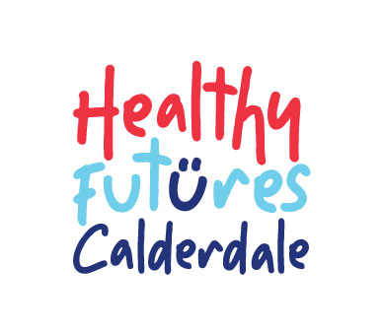Public Health Directorate

Halifax Town Hall

Crossley Street

Halifax

HX1 1UJ

Dear parent/carer,

This letter sets out some important information about your child having their height and weight measured as part of the National Child Measurement Programme (NCMP).

### Height and weight checks for children in Reception and Year 6

Every year in England, school children in reception and year 6 have their height and weight checked at school as part of the National Child Measurement Programme (NCMP). Height and weight measurements are used to calculate weight status. We collect this information to build a picture of how children are growing, to help plan better health and leisure services for families. Your child’s class will take part in this year’s programme.

**The checks are carried out sensitively by registered school nurses or trained school nurse assistants. Children are measured fully clothed, except for their coats and shoes, in a private space away from other pupils.** The programme will be delivered in a safe way, in line with the school and local authority’s safety control measures and national guidance for schools and healthcare.

If your child’s results suggest that they are underweight or overweight, we will try to contact you to discuss how we can help.

If you are concerned about your child’s growth, weight, body image or eating patterns, you can seek further support from the Healthy Futures Calderdale school nursing team on **0300 304 5555.**

##### **Maintaining the wellbeing of children in the NCMP**

The wellbeing of children and families is very important. Measurements are conducted in a sensitive way, in private and away from other children. **Individual results are not shared with your child or their school.**

The emotional impact of the NCMP has been researched and studies show that body image, self-esteem, weight-related teasing and restrictive eating behaviours do not change as a result of being measured or receiving feedback.

**The information we collect and how it is used**

Over the page, you can find out more about the information collected as part of the NCMP and how it is used.

#### Withdrawing your child from the NCMP

If you are happy for your child to be measured, you do not need to do anything.

**If you do not want your child’s height and weight to be checked, or your child has a medical condition that affects their height or weight please let us know within seven days of receipt of this letter by contacting the school nursing team on 0300 304 5555.**

Children will not be made to take part on the day if they do not want to.

**Advice and support from the Healthy Futures Calderdale school nursing team**

If you have any concerns about your child’s health or wellbeing, the Healthy Futures Calderdale school nursing team can be contacted by phone on **0300 304 5555**, or by text using ChatHealth, our secure and confidential text messaging service for school-aged children and their families in Calderdale. Parents/carers can text: **07507 332157**, and young people can get in touch by texting **07480 635297**.

You can find further information about the NCMP at [The National Child Measurement Programme](https://www.nhs.uk/live-well/healthy-weight/childrens-weight/national-child-measurement-programme/) NHS webpage.

You can find information and fun ideas to help your kids stay healthy at the NHS Better Health: healthier families webpage [Easy ways to eat well and move more](https://www.nhs.uk/healthier-families/).

For emotional health and wellbeing support, The Solihull approach offers free courses for all parents, carers, grandparents and teens from bump to 19+ years. Calderdale residents can access these courses for free by scanning the QR code below and entering Access Code: TKPARENTS

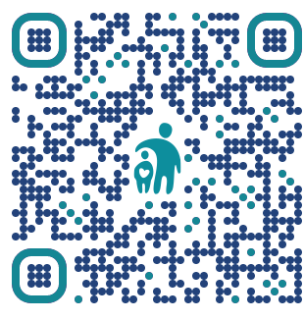

Yours faithfully

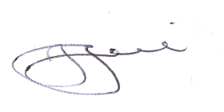

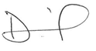

Deborah Harkins Julie Jenkins

Director of Public Health Director of Children and Young People’s Services

Calderdale MBC Calderdale MBC

**How your child’s data is collected and processed as part of the National Child Measurement Programme (NCMP)**

Local authorities have a legal duty to collect the NCMP data. They do this by following guidance from the Office for Health Improvement and Disparities part of the Department of Health and Social Care (DHSC). Local authorities are responsible for making decisions on how the data is collected and for making sure it is protected. Local NCMP service providers are contracted to carry this out; this might be through the school nursing team working in schools or a local healthcare provider. The team collecting the data enter it into the NCMP IT system, which is provided by NHS Digital. The data may also be entered into a local child health information system. Your local authority is responsible for sending the data to NHS Digital. NHS Digital and the Office for Health Improvement and Disparities are jointly responsible for the data held at a national level. Your local authority is responsible for the data held locally.

**The information we collect and what it is used for**

Your child’s height, weight, date of measurement, sex and date of birth are used to calculate your child’s weight category (also known as body mass index, or BMI).

Your child’s name, date of birth and NHS Number are used to link your child’s measurements in reception and year 6.

Other data sets held by NHS England and Department of Health and Social Care (DHSC) may also be linked to allow information from health and education records to be added, where lawful to do so. This helps understand how and why the weight of children is changing, and how this affects children’s health and education and how the care children receive can be improved. These other data sets may include your child’s health data relating to:

* their birth
* hospital care (including time in hospital and out-patient appointments and diagnosis of medical conditions)
* mental health
* social care
* primary care (including all healthcare outside of hospital, such as GP and dental appointments)
* public health (including data relating to preventing ill health, such as immunisation records)
* records for when and the reason why people pass away
* medical conditions, such as cancer and diabetes
* health, lifestyle and wellbeing surveys that your child has participated in

Your child’s ethnicity and address are used to help understand some of the reasons for the difference and changes in child weight across England.

#### Why we need your contact details

We need your address to send you your child’s feedback letter. This will include your child’s measurements together with information about healthy eating, being active and related activities available in your area [local authority to amend as appropriate].

We need your email address and phone number because we may:

* contact you by email or phone to discuss your child’s feedback
* send you your child’s feedback letter by email
* offer you further support following your child’s height and weight measurement

#### How the data is used

**All the data collected is also used for research and planning to improve health, care and services.**

**All this information is treated confidentially and held securely. No individual measurements will be given to school staff or other children.**

The information collected from all schools in the area will be gathered together and held securely by Calderdale Council. We will store your child’s information as part of the local child health record on the NHS’s child health information database.

We will send all the information collected about your child to NHS England. NHS England is responsible for collecting data and information about health and care so that it can be used to monitor and improve the care provided to people across England.

The information collected about your child will also be shared by NHS England with the Office for Health Improvement and Disparities (OHID) which is part of DHSC but in a de-personalised form only. This means OHID will not be able to identify your child.

Both NHS England and OHID will use the information from the NCMP to better understand numbers and trends in child weight and BMI. This helps to plan services to support healthy lifestyles in your area. No information will ever be published by NHS England or OHID that identifies your child. NHS England uses the data to produce [National Child Measurement Programme statistics reports](https://digital.nhs.uk/data-and-information/publications/statistical/national-child-measurement-programme) showing trends at national and local level.

De-personalised information from the NCMP may also be shared by NHS England with other organisations, such as universities. This is to help improve health, care and services through research and planning. This information cannot be used to identify your child. NHS England only ever shares information for research through formal assurance and approvals processes, seeking advice from experts as necessary.

**The chart below displays what happens to your child’s data as part of the NCMP.**

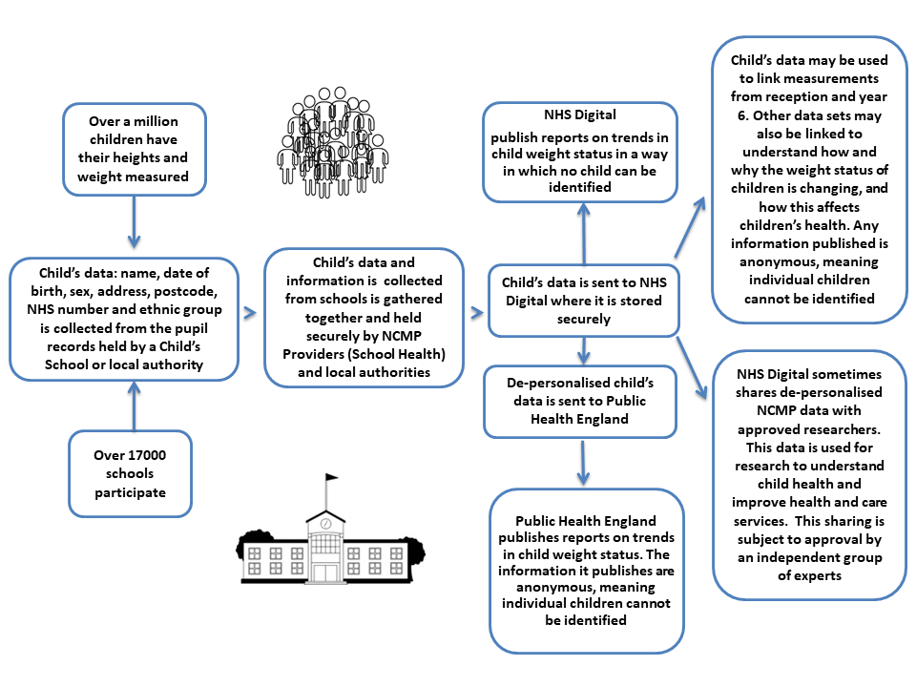

**Further information about the National Child Measurement Programme**

Further information about the National Child Measurement Programme can be found at [https://www.nhs.uk/live-well/healthy-weight/national-child-measurement-programme](https://www.nhs.uk/live-well/healthy-weight/national-child-measurement-programme/)

Information about how Calderdale MBC and Locala Community Partnerships collect and use information can be found at

<https://www.calderdale.gov.uk/v2/council/data-and-information/data-protection-and-freedom-information/data-protection/privacy-notices>

and

<https://www.locala.org.uk/about-us/how-we-are-doing/information-governance/privacy-notice-gdpr-information/>

Information about how NHS Digital and OHID collect and use information can be found at <https://digital.nhs.uk/about-nhs-digital/our-work/keeping-patient-data-safe/how-we-look-after-your-health-and-care-information> and <https://www.gov.uk/government/organisations/department-of-health-and-social-care/about/personal-information-charter>

Information about the organisations NHS Digital has shared information from the National Child Measurement Programme can be found at [https://digital.nhs.uk/services/national-child-measurement-programme](https://digital.nhs.uk/services/national-child-measurement-programme/).